**System Requirement Specification Document**

*for*

***RTO* *Management* *System***

**Team:** Citizens, RTO Staff, Architect, Business Analyst, Quality Assurance Team, System Analyst.

**Objective (Purpose):**

The online RTO Management Web Application is intended to provide complete solution for Citizens, RTO Staff through a single Gateway using internet. It will enable Citizens and RTO staff to access information, modify information online without visiting the RTO office physically.

RTO (Regional Transport Office) system is an application that is designed for the RTO for the process of registration of vehicles and issuing Driving license, Learning License, Owner Ship Transfer based web Application. RTO Information System is an online information source developed for Road Transport Authority to facilitate the users in applying for various licenses and registrations.

**Scope:**

This System allows Citizens to view, modify their information by adding or removing their information from the previous record.

This system allows Citizens to apply for Driver license, Learning License, Vehicle registration, Vehicle permit, Transfer ownership.

This system allows RTO Staff to Control Driving license, Learning license, Vehicle registration, Ownership transfer, Vehicle permit, Payments, Complaints.

**Definitions:**

RM: RTO Management System

Portal: Personalized Online Web Application

MIS: Management Information System

CRM: Citizens Relation Management

BI: Business Intelligence

**Dashboard:** Personalized information presented using BI techniques such as tables, graphs.

**Functional Requirements:**

* Any anonymous User will be able to register and able to view about us. Registered citizens will be able to view, modify their details and able to see the status of the request which is under process.
* RTO staff will be able to accept, reject the request of citizens.
* RTO staff will be able modify details of citizens.
* RTO staff will be able to view and manage different tables i.e. Driving license table, Learning license table, Complaint table, RC table, Citizens details table, Payment table, Vehicle transfer table, PUC table.
* Dashboard will provide information using graph, tables, key performance indicators as well Grid data prestation.
* System and Technical team (IT Operations team) will be able to monitor system operations by monitoring logs maintained.

**Non-Functional Requirement:**

**Security:**

* Registered Citizens will be allowed to access their personal details.
* Each RTO Staff will be able to access system through **Authentication** process.
* System will provide access to the content, operations using Role based security i.e. **Authorization**
* Using Secure Socket Layer (SSL) in all transactions which will be performed by RTO staff. It would protect confidential information shared by system to RTO Staff.
* System will automatically log of all RTO Staff after some time due to inactiveness.
* System will block operations for inactive RTO Staff and would redirect for authentication.
* System will internally maintain secure communication channel between Servers (Web Servers, App Servers, Database Server)
* Sensitive data will be always encrypted across communication.
* Using proper firewall to protect servers from outside fishing, vulnerable attacks.

**Reliability:**

* The system will backup data on regular basis and recover in short time duration to keep system operational.
* Continuous updates are maintained, continuous administration is done to keep system operational.
* During peak hours system will maintain same user experience by managing load balancing.

**Availability:**

* Uptime: 24* 7 available.

**Maintainability:**

* A Commercial database software will be used to maintain System data Persistence.
* A readymade Web Server will be installed to host online shopping portal (Web Site) to management server capabilities.
* IT operations team will easily monitor and configure System using Administrative tools provided by Servers.
* Separate environment will be maintained for system for isolation in production, testing, and development.

**Portability:**

* PDA: Portable Device Application
* System will provide portable User Interface (HTML, CSS, JS, React) through which users will be able to access online RTO Management System.
* System can be deployed to single server, multiple server, to any OS, Cloud (Azure or AWS or GCP)

**Accessibility:**

* Only registered Citizens will be able to access theirs details after authentication.
* RTO staff team can reject or approve different requests from citizens.
* RTO staff team will be able to view daily, weekly, monthly and annual reports of requests of citizens through customized dashboard.
* Citizens can see their status of requests.

**Durability:**

* System will retain citizens details for 15 minutes even though citizens loose internet connection and join again or inactiveness after that it will be redirected to authentication.
* System will implement backup and recovery for retaining RTO’s data, operation data over time.

**Efficiency:**

* On heavy traffic, System will be able to manage all transactions with isolation with same response time.

**Modularity:**

* System will be designed and developed using reusable, independent or dependent scenarios in the form of modules.
* These modules will be loosely coupled and highly cohesive.
* System will contain CRM, Driving license module, Payment module, Vehicle Registration module, Membership and Roles management module.

**Scalability:**

* System will be able to provide consistent user experience to RTO staff as well as citizens irrespective of load.

**Safety:**

* Online RTO management portal will be secure from malicious attack, fishing.
* Online RTO management portal functionalities are protected from outside with proper firewall configuration.
* Online RTO management portal will be always kept updated with latest antivirus software.
* RTO’s data will be backed up periodically to ensure safety of data using incremental back up strategy.
* Role based security will be applied for Application data and operations accessibility.

**Performance requirement:**

* **Hardware Requirement:**

|  |  |
| --- | --- |
| **RAM** | 4 GB |
| **Hard Disk** | 500 GB |
| **Processor** | Quad Core |

* **Software Requirement:**
  + **Client Side:**

|  |  |
| --- | --- |
| **Web Browser** | Google Chrome or any compatible browser |
| **Operating System** | Windows or any equivalent OS |

* + **Server Side:**

|  |  |
| --- | --- |
| **Web Server** | TOMCAT |
| **Server Side Language** | React |
| **Database** | MySQL |
| **Web Browser** | Google Chrome or any compatible browser |
| **Operating System** | Windows or any equivalent OS |

**Analysis:**

**Actors:**

* RTO Staff
* Citizen

**Use cases:**

* Citizens authentication and details management use case
* RTO’s staff authentication and functionality use case
* Citizen’s Request Processing use case
* Membership use case
* Payments use case
* Vehicle Registration use case
* Customer Relation Management (CRM) use case
* Business Intelligence use case

**Flow Diagram:**

1. **RTO Modules Flow Diagram:**

**RTO Module**

**Driving license Module**

**Payment Module**

**Membership and Roles management Module**

**CRM**

**Module**

**Vehicle Registration Module**

1. **Citizen Flow Diagram:**

**Citizen**

**Login**

**(Authentication)**

**Add/Update Details**

**Apply DL/LL**

**Register Complain**

**View Request Status**

**Apply Vehicle Registration**

**Apply Vehicle Ownership Transfer**

**Apply Permit**

1. **RTO Staff Flow Diagram:**

**Citizens Details**

**Permit**

**Vehicle Ownership Transfer**

**RC**

**DL/LL**

**Complain**

**Status**

**Accept/Reject**

**Requests**

**Update**

**View**

**Login**

**(Authentication)**

**RTO Staff**

**4. System Flow Diagram––:**

Citizen

Is Registered?

Registration

Admin No

Yes

Login

No

Is Valid?

Yes

(Admin) YesNo(Citizen)

View DL/LL/Complain/RC

Is RTO Staff?

Vehicle Registration

View Permit/Payment

Apply DL/LL/Permit

View/Update Citizens

Payment/Complain

Update DL/LL/Complain/RC

DL/LL/RC/Permit Status

View/Update Vehicle Ownership Transfer

Apply/View Vehicle Ownership Transfer Status

Logout

**Use Case Diagram:**

1. **Use case diagram for Citizen**

1. **Use case diagram for RTO Staff**

**Data Flow Diagram:**

**Zero Level DFD:**

**Login Management**

**Citizen Management**

**License Management**

**Complain Management**

**Vehicle Registration Management**

**RTO Staff Management**

**First Level DFD:**

**Check Login Details**

**Login Management**

**License Management**

**Generate Citizen Details**

**Generate RTO Staff Details**

**Citizen Management**

**RTO Staff Management**

**Generate Vehicle Registration Details**

**Generate Driving License Details**

**Complain Management**

**Generate Citizen Details**

**Vehicle Registration Management**

**Generate Status Details**

**Second Level DFD:**

**Citizen/RTO Staff**

**Manage Vehicle Registration Details**

**Manage Citizen’s Details**

**Manage Driving License Details**

**Manage Payment Details**

**Manage RTO Staff Details**

**Manage Citizen Permission**

**Manage Reports/Status**

**E-R Diagram:**

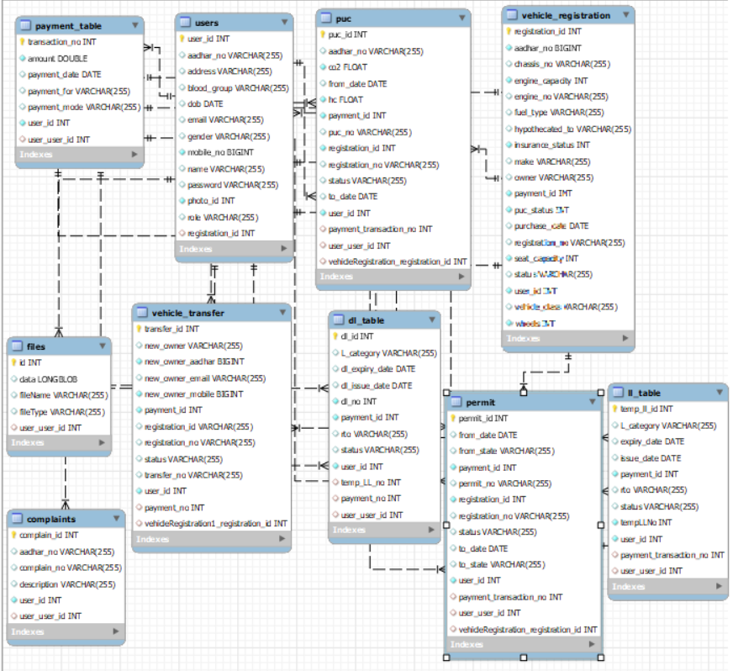

**Database Design:**

* **Citizen/RTO Staff (users):**

|  |  |
| --- | --- |
| **Table Name** | users |
| **Description** | This table contains details of Citizens |
| **Primary Key** | id |
| **Foreign Key** | registration_id |

|  |  |  |  |  |
| --- | --- | --- | --- | --- |
| **S No.** | **Field Name** | **Data type** | **Constraint** | **Description** |
| 1 | user_id | int | Primary key | It stores Citizen’s id |
| 2 | aadhar_no | varchar | Unique | It stores Citizen’s aadhar number |
| 3 | Name | varchar | Not null | It stores Citizen’s name |
| 4 | address | varchar | Not null | It stores Citizen’s address |
| 5 | gender | varchar | Not null | It stores Citizen’s gender |
| 6 | Dob | date | Not null | It stores Citizen’s date of birth |
| 7 | blood_group | varchar | Not null | It stores Citizen’s blood group |
| 8 | mobile_no | long | Not null | It stores Citizen’s mobile number |
| 9 | email | varchar | Not null | It stores Citizen’s email |
| 10 | password | varchar | Not null | It stores Citizen’s password |
| 11 | registration_id | int | Not null | It stores Registration details |
| 12 | role | varchar | Not null | It stores specific roles |
| 13 | photo_id | int | Not null | It stores photo |

* **Vehicle Registration:**

|  |  |
| --- | --- |
| **Table Name** | vehicle_registration |
| **Description** | This table contains details of vehicle registrations |
| **Primary Key** | registration_id |
| **Foreign Key** | registration_id |

|  |  |  |  |  |
| --- | --- | --- | --- | --- |
| **S No.** | **Field Name** | **Data type** | **Constraint** | **Description** |
| 1 | registration_id | int | Primary key | It stores vehicle registration id |
| 2 | registration_no | varchar | Not null | It stores vehicle registration no |
| 3 | owner | varchar | Not null | It stores vehicle owner name |
| 4 | make | varchar | Not null | It stores vehicle make detail |
| 5 | chassis_no | varchar | Not null | It stores vehicle chassis no |
| 6 | purchase_date | date | Not null | It stores vehicle purchase date |
| 7 | vehicle_class | varchar | Not null | It stores vehicle class detail |
| 8 | fuel_type | long | Not null | It stores vehicle fuel type |
| 9 | engine_capacity | int | Not null | It stores vehicle engine capacity detail |
| 10 | engine_no | varchar | Not null | It stores vehicle engine no |
| 11 | insurance | int | Not null | It stores vehicle insurance detail |
| 12 | wheels | int | Not null | It stores vehicle wheels detail |
| 13 | payment_id | int | Not null | It stores vehicle payment id |
| 14 | status | varchar | Not null | It stores vehicle status detail |

* **Vehicle Transfer**

|  |  |
| --- | --- |
| **Table Name** | vehicle_transfer |
| **Description** | This table contains details of vehicle ownership transfer |
| **Primary Key** | transfer_id |
| **Foreign Key** | - |

|  |  |  |  |  |
| --- | --- | --- | --- | --- |
| **S No.** | **Field Name** | **Data type** | **Constraint** | **Description** |
| 1 | transfer_id | int | Primary key | It stores vehicle transfer id |
| 2 | transfer_no | varchar | Not null | It stores vehicle transfer no |
| 3 | new_owner | varchar | Not null | It stores vehicle new owner name |
| 4 | new_owner_aadhar | long | Not null | It stores vehicle new owner aadhar |
| 5 | new_owner_email | varchar | Not null | It stores vehicle new owner email |
| 6 | registration_id | int | Not null | It stores vehicle registration id |
| 7 | registration_no | varchar | Not null | It stores vehicle registration no |
| 8 | new_owner_mobile | long | Not null | It stores vehicle new owner mobile number |
| 9 | citizen_id | int | Not null | It stores citizen id |
| 10 | payment_id | Int | Not null | It stores payment id |
| 11 | status | varchar | Not null | It stores status detail |

* **Payment**

|  |  |
| --- | --- |
| **Table Name** | payment_table |
| **Description** | This table contains details of payment |
| **Primary Key** | transaction_no |
| **Foreign Key** | - |

|  |  |  |  |  |
| --- | --- | --- | --- | --- |
| **S No.** | **Field Name** | **Data type** | **Constraint** | **Description** |
| 1 | transfer_no | int | Primary key | It stores vehicle transfer no |
| 2 | payment_for | varchar | Not null | It stores payment made for detail |
| 3 | payment_mode | varchar | Not null | It stores payment mode detail |
| 4 | amount | double | Not null | It stores amount detail |
| 5 | citizen_id | int | Not null | It stores citizen id |
| 6 | payment_date | date | Not null | It stores payment date |

* **Complain**

|  |  |
| --- | --- |
| **Table Name** | complaints |
| **Description** | This table contains details of complain posted by citizens |
| **Primary Key** | complain_id |
| **Foreign Key** | - |

|  |  |  |  |  |
| --- | --- | --- | --- | --- |
| **S No.** | **Field Name** | **Data type** | **Constraint** | **Description** |
| 1 | complain_id | int | Primary key | It stores complain id |
| 2 | complain_no | varchar | Not null | It stores complain no |
| 3 | description | varchar | Not null | It stores description of complaint |
| 4 | citizen_id | int | Not null | It stores citizen id |

* **Driving License**

|  |  |
| --- | --- |
| **Table Name** | dl_table |
| **Description** | This table contains details of Driving License |
| **Primary Key** | dl_id |
| **Foreign Key** | - |

|  |  |  |  |  |
| --- | --- | --- | --- | --- |
| **S No.** | **Field Name** | **Data type** | **Constraint** | **Description** |
| 1 | dl_id | int | Primary key | It stores driving license id |
| 2 | dl_no | int | Not null | It stores driving license no |
| 3 | payment_id | int | Not null | It stores payment id |
| 4 | status | varchar | Not null | It stores driving license status |
| 5 | citizen_id | int | Not null | It stores citizen id |
| 6 | dl_issue_date | date | Not null | It stores driving license issue date |
| 7 | dl_expiry_date | date | Not null | It stores driving license expiry date |
| 8 | rto | varchar | Not null | It stores rto details |
| 9 | L_Category | Varchar | Not Null | It stores License category |

* **Learning License**

|  |  |
| --- | --- |
| **Table Name** | ll_table |
| **Description** | This table contains details of Learning License |
| **Primary Key** | temp_ll_id |
| **Foreign Key** | - |

|  |  |  |  |  |
| --- | --- | --- | --- | --- |
| **S No.** | **Field Name** | **Data type** | **Constraint** | **Description** |
| 1 | temp_ll_id | int | Primary key | It stores learning license id |
| 2 | dl_no | int | Not null | It stores learning license no |
| 3 | payment_id | int | Not null | It stores payment id |
| 4 | status | varchar | Not null | It stores learning license status |
| 5 | citizen_id | int | Not null | It stores citizen id |
| 6 | issue_date | date | Not null | It stores learning license issue date |
| 7 | expiry_date | date | Not null | It stores driving license expiry date |
| 8 | rto | varchar | Not null | It stores rto details |
| 9 | L_category | Varchar | Not Null | It stores license category |

* **Payment**

|  |  |
| --- | --- |
| **Table Name** | payment_table |
| **Description** | This table contains details of payments |
| **Primary Key** | transaction_no |
| **Foreign Key** | - |

|  |  |  |  |  |
| --- | --- | --- | --- | --- |
| **S No.** | **Field Name** | **Data type** | **Constraint** | **Description** |
| 1 | transaction_no | int | Primary key | It stores payment id |
| 2 | Amount | int | Not null | It stores amount |
| 3 | payment_date | Date | Not null | It stores payment date |
| 4 | Payment_for | varchar | Not null | It stores for which category payment is done |
| 5 | citizen_id | int | Not null | It stores citizen id |
| 6 | Payment_mode | varchar | Not null | It stores payment mode |

* **Permit**

|  |  |
| --- | --- |
| **Table Name** | permit |
| **Description** | This table contains details of vehicle permit |
| **Primary Key** | permit_id |
| **Foreign Key** | - |

|  |  |  |  |  |
| --- | --- | --- | --- | --- |
| **S No.** | **Field Name** | **Data type** | **Constraint** | **Description** |
| 1 | permit_id | int | Primary key | It stores permitid |
| 2 | From_date | Date | Not null | It stores from date |
| 3 | From_state | Varchar | Not null | It stores from state |
| 4 | Payment_id | Int | Not null | It stores payment id |
| 5 | citizen_id | Int | Not null | It stores citizen id |
| 6 | Permit_no | Varchar | Not null | It stores permit no |
| 7 | Registration_id | Int | Not null | It stores registration id |
| 8 | Registration_no | Varchar | Not null | It stores registration no |
| 9 | status | Varchar | Not Null | It stores status |
| 10 | To_date | Date | Not Null | It stores to date |
| 11 | To_state | Varchar | Not Null | It stores to state |
| 12 | Payment_transaction_no | Int | Not Null | It stores payment transaction no |

* **Puc**

|  |  |
| --- | --- |
| **Table Name** | puc |
| **Description** | This table contains details of vehicle puc |
| **Primary Key** | puc_id |
| **Foreign Key** | - |

|  |  |  |  |  |
| --- | --- | --- | --- | --- |
| **S No.** | **Field Name** | **Data type** | **Constraint** | **Description** |
| 1 | puc_id | int | Primary key | It stores puc id |
| 2 | Aadhar_no | varchar | Not null | It stores aadhar no |
| 3 | Co2 | float | Not null | It stores from CO2 value |
| 4 | From_date | date | Not null | It stores from date |
| 5 | HC | float | Not null | It stores Hydrocarbo value |
| 6 | Payment_id | int | Not null | It stores payment id |
| 7 | Puc_no | varchar | Not null | It stores puc no |
| 8 | Registration_no | varchar | Not null | It stores registration no |
| 9 | Registration_id | int | Not Null | It stores registration id |
| 10 | To_date | Date | Not Null | It stores to date |
| 11 | status | Varchar | Not Null | It stores to status |
| 12 | Payment_transaction_no | Int | Not Null | It stores payment transaction no |

**Conclusion:** It can be concluded that our project "RTO Management System" which is an Automation of Road Transport Department was successfully developed and tested by our team. Our system introduces a facility for the RTO Officers to perform verification of the License and Vehicle documents electronically. It will also help the RTO officials to maintain records systematically and reduces a lot of paper work and manual efforts. We also identified some general requirements of such a system and tried to meet those requirements as much as possible.